**Animation**

Demonstrations of Key Frame Animations, using X3D’s TimeSensor, PositionInterpolator, OrientationInterpolator and ROUTE’s. There is no interactivity. Nearly all the demo’s set the <Viewpoint/> node positioned at 0, 0, 0 or 0, 0, 10; and there is a Background color in each.

**animation01.x3d**

The plane textured with “Marker ONE” animates in a triangle pattern, though it does not return to its original position. The dog does not animate. Both planes are rotated.

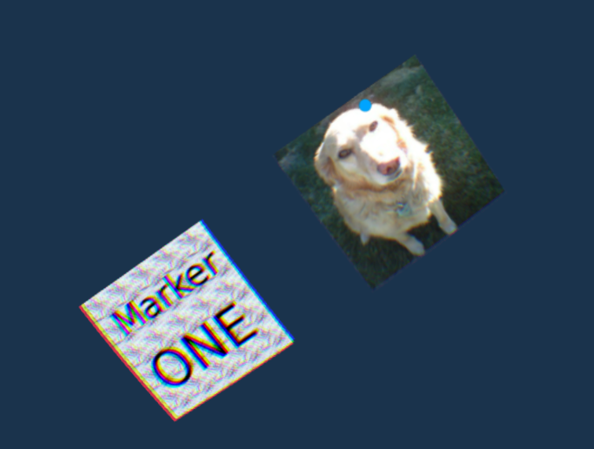

**animation02.x3d**

There is a plane with “North-East-West-South”. In front of that is a one-sided plane with a pinwheel texture so only 50% of the time it is visible. You can even see the impact of the single Point Light as the pinwheel plane animates. The camera is at the default (0,0,10) since no <Viewpoint/> is specified.

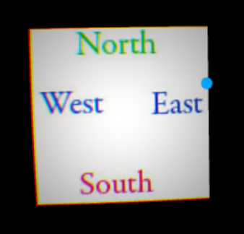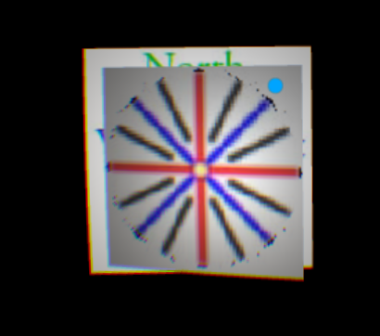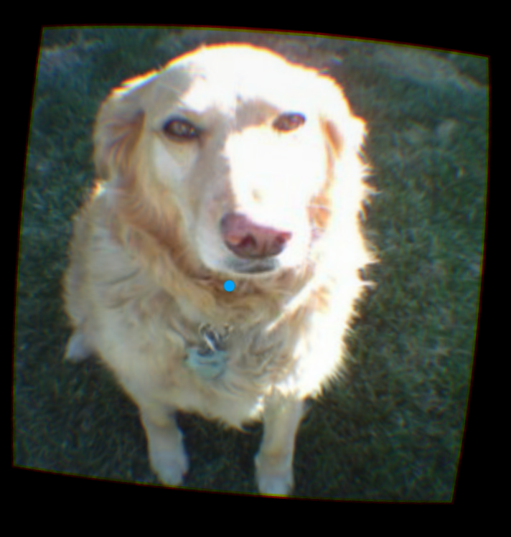

Rotating the phone 180 degrees around the y-axis, reveals a textured plane with a dog.

**animation03.x3d**

Two animations with different timers. The white pattern rotates around the y-axis. It is a one-sided plane, but the rotation is from -90 degrees to +90 degrees. The other two angled planes translate from the back left, toward the center, and then to the lower back right. Marker TWO and the yellow-black stripes are with the same <Transform> and thus follow the same animation.

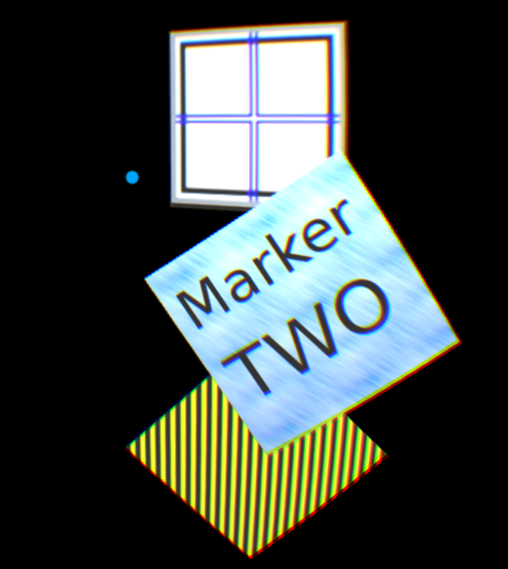

**animation04.x3d**

There are two animations here. The center has a patterned plane that rotates from 90 degrees to -90 degrees, with a child plane rotating around it (like a moon around a planet) textured with “North-East-West-South”. Another object is animated from the lower right and upper left. Marker Two has a child plane behind it with the yellow and black texture map.

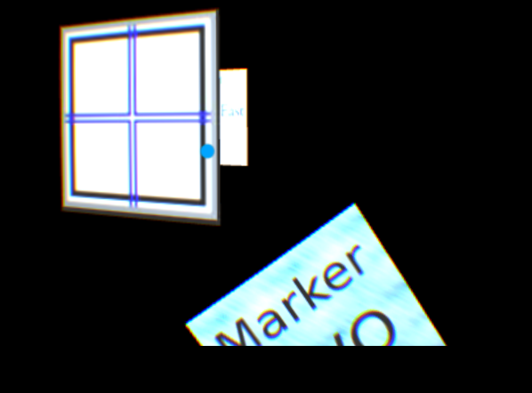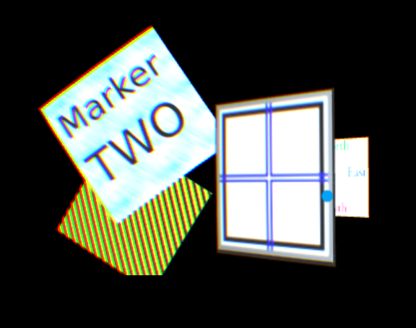

**animation05.x3d**

The center panel with the test pattern rotates from -90 degrees to + 90 degrees around the y-axis in 9 seconds. It has a child object 2 units in front of it that has the same rotation, but only 3 seconds, thus it will perform 3 times more rotations.

There are two other panels in the scene, Marker TWO and the yellow-black pattern that perform position animations. They share a 7-second time sensor, but separate position interpolators.

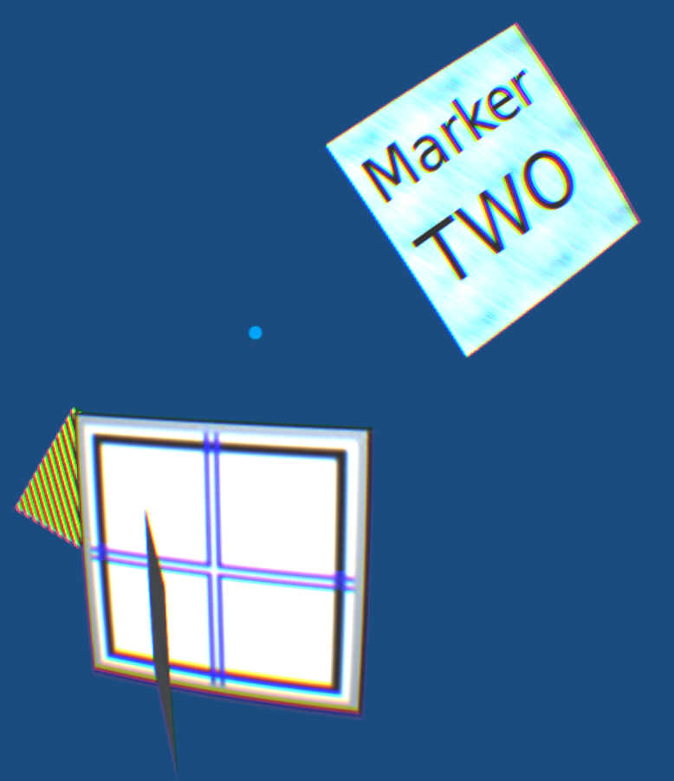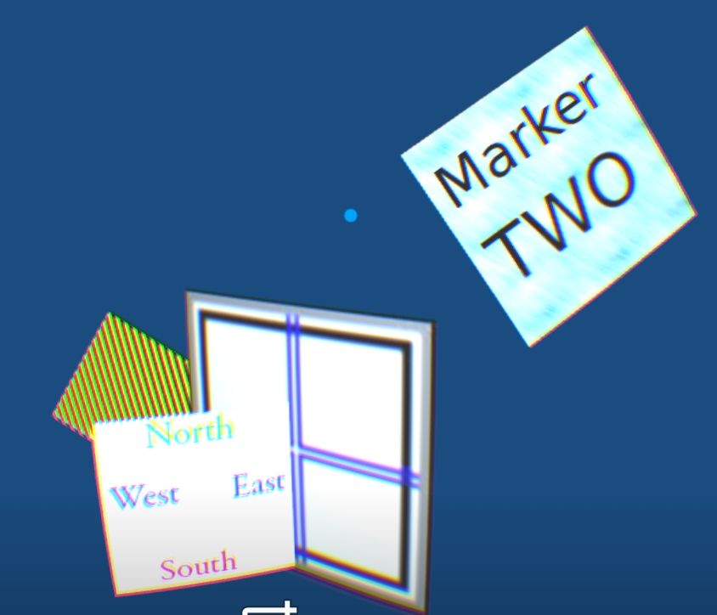

**animation06.x3d**

The single panel rotates -90 degrees to +90 degrees and translates from upper left to lower right. Several lights in the scene will give it a blue tinge when facing toward the –X axis, and yellow tinge when facing toward the + X axis.

